PROJECT BASED LAB REPORT
On
HOUSE TAX BILLING SYSTEM
Submitted in partial fulfilment of the
Requirements for the award of the Degree of
Bachelor of Technology
in
ELECTRONICS AND COMMUNICATION ENGINEERING
By
ROHINI PANDIRI - 2100031934



DEPARTMENT OF ELECTRONICS AND COMMUNICATION ENGINEERING

K L University
Green Fields, Vaddeswaram, Guntur District-522 502
2016-2017

K L University
DEPARTMENT OF ELECTRONICS AND COMMUNICATION ENGINEERING

CERTIFICATE

This is to certify that this project based lab report entitled “HOUSE TAX BILLING SYSTEM” is a bonafide work done by ROHINI PANDIRI (2100031934) in partial fulfilment of the requirements for the award of degree in BACHELOR OF TECHNOLOGY in ELECTRONICS AND COMMUNICATION ENGNEERING during the Academic year 2016-2017.

Faculty in Charge Head of the Department
K L University
DEPARTMENT OF ELECTRONICS AND COMMUNICATION ENGINEERING

DECLARATION

We hereby declare that this project based lab report titled “HOUSE TAX BILLING SYSTEM” has been prepared by us in partial fulfilment of the requirements for the award of degree “BACHELOR OF TECHNOLOGY in ELECTRONICS AND COMMUNICATION ENGNEERING” during the Academic year 2016-2017.
We also declare that this project based lab report is of our own efforts and it has not been submitted to any other university for the award of any degree.

ROHINI PANDIRI
2100031934

ACKNOWLEDGEMENT

Our sincere thanks to DR.M.JAYA BHASKAR in the Lab for their outstanding support through out the project for the successful completion of the work.
We express our gratitude to DR.A.S.C.S.SASTRY, Head of the Department for Electronics and communication Engineering for providing us with adequate facilities, ways and means by which we are able to complete this project based Lab.
We would like to place on record the deep sense of gratitude to the honourable Vice Chancellor, K L University for providing the necessary facilities to carry the project based Lab.
Last, but not the least, we thank all Teaching and Non-Teaching Staff of our department and especially my classmates and my friends for their support in the completion of our project based Lab.

CONTENTS
- Abstract ………………….. 6
- Introduction ………………….. 7
- Modules description …………………. 8
3.1.1 Managing customer records
3.1.2 Managing the House Tax bills
3.1.3 Tracking bill status
3.1.4 Menu design and Integrating of all modules
- Source code ………………….. 10
- Snap shots of the output …………………. 39
- References ………………….. 40

DESCRIPTION :
Main aim of this project is to implement an application which deals with maintaining house tax activities like generating house tax bill, Customer personal records and other Administration activities. Initially, all the information about residence and the address will be entered and maintained, which in turn helps to generate an House Tax bill .This system will reduce manual work for maintaining records in files.
This system provides new mechanism in maintaining house tax records effectively. Regular transactions which include bill generation, payment etc. and exceptional transactions that are related to, change of customer’s address, not clearing bills within due date etc. also will have to be handled by the system
Function Identification - module wise
Module Number | Module Name | S. No. of function | Function
 | Managing Customer records |  | To create customer file
 | Managing Customer records |  | To update customer file
 | Managing Customer records |  | To generate Reports
 | Managing Customer records |  | To search for customer information
 | Managing the House tax bills |  | To create Bills file
 | Managing the House tax bills |  | To update Bills file
 | Managing the House tax bills |  | To generate Reports
 | Tracking bill status |  | To update payments
 | Tracking bill status |  | To notify defaulters
 | Tracking bill status |  | To generate Reports
4. | Menu design and integrating of all modules |  | To display system banner.
4. | Menu design and integrating of all modules |  | To process menu.
4. | Menu design and integrating of all modules |  | Integration of all the modules
4. | Menu design and integrating of all modules |  | To provide security

HOUSE TAX BILLING SYSTEM
2. INTRODUCTION
Our objective is to ensure transparency in the House tax collect House department will be provided with the mobile phone handsets and the printers. The data will be immediately transferred to the server in the headquarters of the municipal corporation. on system as it will save both time and manpower in the process. At present, the reading of House tax billing is done manually by the municipal employees, who upload the data on computer and get printouts of the water tax billings that are again distributed among the consumers.
Telecommunication companies need an effective and accurate billing system to be able to assure their revenue. Billing systems process the usage of network equipment that is used during the service usage into a single Call Detail Record (CDR). The billing process involves receiving billing records from various networks, determining the billing rates associated with the billing records, calculating the cost for each billing record, aggregating these records periodically to generate invoices, sending invoices to the customer, and collecting payments received from the customer. Billing system is very complex starting from network elements that generate usage to the billing system to usage collection, mediation, rating, and invoicing. To simplify the process I will introduce a simple system usage scenario as shown in the following figure. The system user navigates through the company site and views company services, and he decides to order one of the available services. If he has no account, he signs up for a new account, else he signs in. Then the user asks to conduct an order with the selected service. The service may be prepaid where he has to pay to have credits to use the service, or it may be post-paid, where he has to pay if the service has installation or setup fees, and later on he will pay for his usage of each billing cycle. The billing system should provide service to the user, collect user usage records, and generate invoices of each credit expire, each billing cycle depends on the billing type, collect payments and adjust customers' balances.

→WHAT IS HOUSE TAX?
House tax is the annual amount paid by a land owner to the local government or the municipal corporation of his area. The property includes all tangible real estate property, his house, office building and the property he has rented to others. In India, the municipal corporation of a particular area assesses and imposes the house tax annually or semiannually. The tax amount is based on the area, construction, property size, building etc. The collected amount is mainly used for public services like repairing roads, construction schools, buildings, sanitation

→ Problem Definition:
The House tax billing system is meant for maintaining information of customers. In this House tax of customer is calculated by maintaining different files such as customer information file, bills file, tracking bills to know the status of the bill. All these files are integrated. This menu based programs in java helps the students to save all the details through files in the form of records. Here in file based program all the information can be searched through bill number.
→ Platform Requirements:
Hardware/Software | Hardware / Software element | Specification /version
Hardware | Processor | Intel core to duo
Hardware | RAM | 1 GB
Hardware | Hard Disk | 100 GB
Software | OS | Windows XP
Software | Java and NetBeans IDE

3. Module Description
AIM: - To write the JAVA code for the following program
- Managing Customer records
- Managing the generated bills.
- Tracking bill status
- Menu design and integrating of all modules
3.1. DESCRIPTION OF MODULES

3.1.1. MODULE 1:
Here we will be creating customer file with details like customer name and house number. Here each and every record has to be entered manually through keyboard, where it asks the user to save how many records he need to enter. After entering those records through proper format those details which user gives can be saved. In this module we will be able to search the details of customer which are present in files, where details will be in the form of house type, built in area, location. Here in this module formatter file takes control of all the things for searching the complete details of customer. Here in generating reports we will be able to display all the details of customer file with details in the form of files.

3.1.2. MODULE 2:

Here we will be creating bills information with details like customer name , bill number and bill. Here each and every record has to be entered manually through keyboard, where it asks the user to save how many records he need to enter. After entering those records through proper format those details which user gives can be saved. In this module we will be able to update the details of customer through the records which are present in the form of name. Here we can search those details either through bill no. If any extra details have to be added we will update those details in place of previous details. In this module we will be able to search the details of customer bills which are present in files, where we can search those details through bill number. Here in this module formatter file takes control of all the things for searching the complete details of customer. Here in generating reports we will be able to display all the details of customer bills.

3.1.3. MODULE 3:

Here in these module payments of customer will be updated. Here in this module we need to display the defaulters who pay the tax irregularly. Defaulters should have to pay fine based on the number of days delayed by them. Here in this module we need to display the customer information and bills that have to be paid.

3.1.4. MODULE 4:
After all modules were integrated through files we display System Banner as HOUSE TAX BILLING SYSTEM. Here Processing Menu can be done through switch case statement with all the modules that are present in the file. Here integration is done to all the modules by using switch case. To provide Security we need to add user name and password with login credentials where user will able to access his details with valid login credentials so that he can be able to create files, search a file and display record of that file, where as in admin module the admin also has to access his entire details with username and password where he can be able to do modifications for files that are present in user module.
4. SOURCE CODE
4.1 Module1:
import java.util.*;
import java.io.*;
class Customer{
public static void main(String args[])
throws IOException {
int i,num;
int choice=0;
int aadharno,houseno;
String name,adress;
int searchAadharno=0;
boolean flag=true;
int snum;
Scanner obj = new Scanner(System.in);
while(flag)
{
System.out.println("\n Menu");
System.out.println("1. Create Customer File");
System.out.println("2. Add more records to Customer file");
System.out.println("3. Search by Customer Aadhar number");
System.out.println("4. Generate report");
System.out.println("5.Quit");
System.out.print("Enter your choice: ");
choice = obj.nextInt();
switch(choice){
case 1:
FileWriter fout = new FileWriter("customer.txt");
System.out.print("How many records? ");
num= obj.nextInt();
for(i=0;i<num;i++)
{
System.out.print("enter customer aadhar number:");
aadharno = obj.nextInt();
System.out.print("Enter customer name:");
name=obj.next();
System.out.print("enter house number:");
houseno= obj.nextInt();
System.out.print("enter customer adress:");
adress=obj.next();
System.out.print("\n");
Formatter fmt1 = new Formatter();
fmt1.format("%10d\n%10s\n%4d\n%10s\n",aadharno,name,houseno,adress);
fout.write(fmt1+"\r\012");
}
fout.close();
System.out.println("File is created with given customer details");
break;
case 2:
FileWriter fout1 = new FileWriter("customer.txt",true);
System.out.print("How many records? ");
num= obj.nextInt();
for(i=0;i<num;i++)
{
System.out.print("enter customer aadhar number:");
aadharno =obj.nextInt();
System.out.print("Enter customer name:");
name=obj.next();
System.out.print("enter house number:");
houseno = obj.nextInt();
System.out.print("enter customer adress:");
adress=obj.next();
System.out.print("\n");
Formatter fmt2 = new Formatter();
fmt2.format("%10d\n%10s\n%4d\n%10s\n",aadharno,name,houseno,adress);
fout1.write(fmt2+"\r\012");
}
fout1.close();
System.out.println("new customer records are added");
break;

case 3: snum=0;
System.out.print("enter Aadhar to search customer information: ");
searchAadharno = obj.nextInt();
FileReader fin1 = new FileReader("customer.txt");
Scanner sc1 = new Scanner(fin1);
while(sc1.hasNextInt())
{
aadharno = sc1.nextInt();
name = sc1.next();
houseno= sc1.nextInt();
adress=sc1.next();

if(aadharno==searchAadharno)
{
++snum;
System.out.println("s.no"+" "+"Aadhar no"+" "+"Name"+" "+"House no"+" "+"adress");

Formatter fmt2 = new Formatter();
fmt2.format("%2d %8d %10s %4d %10s",snum,aadharno,name,houseno,adress);

System.out.println(fmt2);
}
}
fin1.close();
break;
case 4:snum=0;
System.out.println("\t\t\tCustomer Details");
FileReader fin3 = new FileReader("customer.txt");
Scanner sc3 = new Scanner(fin3);
System.out.println("s.no"+" "+"Aadhar no"+" "+"Name"+" "+"House no"+" "+"adress");
while(sc3.hasNextInt())
{
aadharno = sc3.nextInt();
name = sc3.next();
houseno= sc3.nextInt();
adress=sc3 .next();
++snum;
Formatter fmt2 = new Formatter();
fmt2.format("%2d %8d %10s %4d %10s",snum,aadharno,name,houseno,adress);
System.out.println(fmt2);
}
System.out.println("End of list");
fin3.close();
break;
case 5: flag=false;
break;
default:System.out.println("Enter correct choice");
}
}
System.out.println("Program is over");
}
}
OUTPUT:
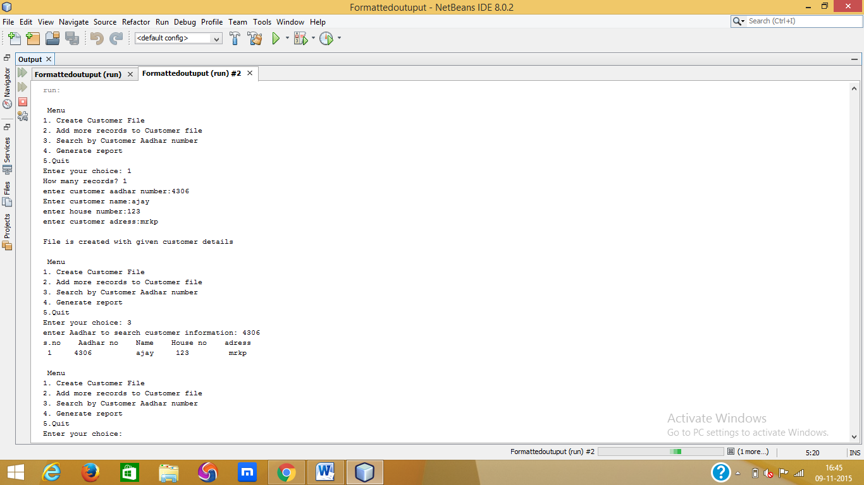

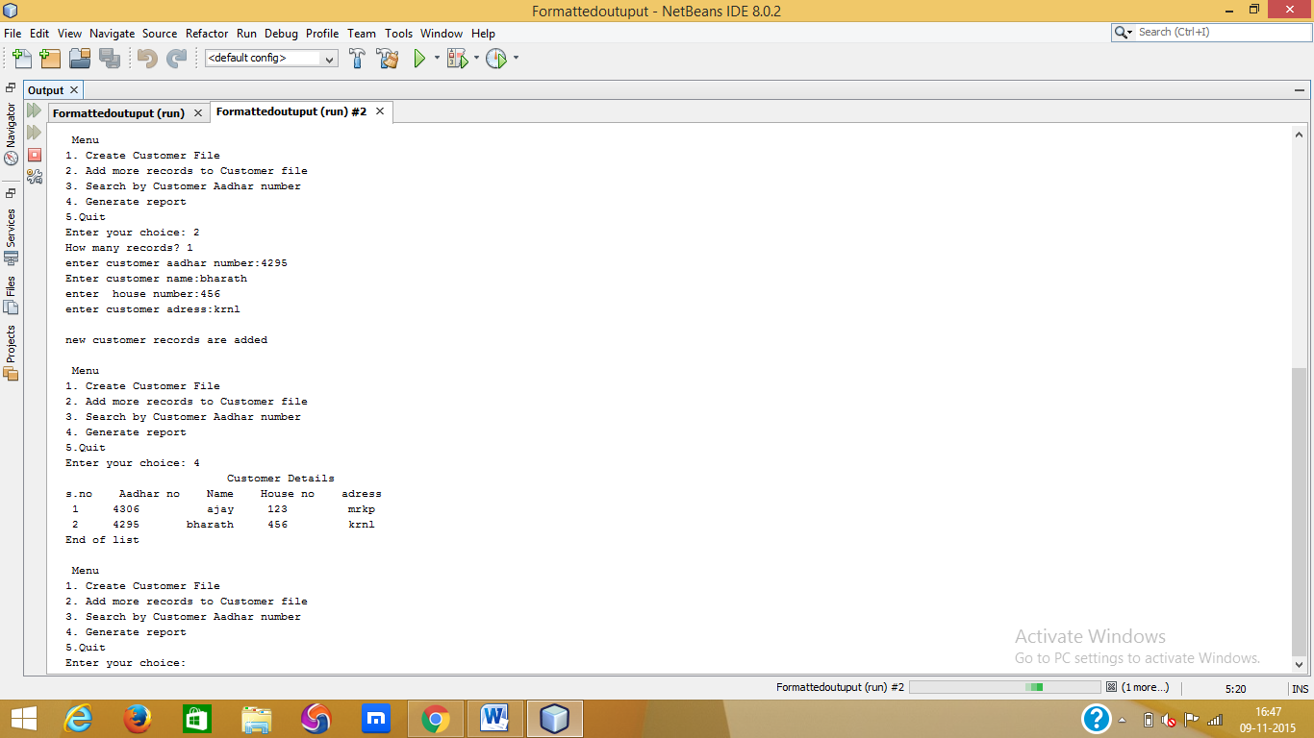

4.2 Module2:
import java.io.FileReader;
import java.io.FileWriter;
import java.io.IOException;
import java.util.Formatter;
import java.util.Scanner;
class Bills3 {
public static void main(String args[])throws IOException {
int i,num;
int choice=0;
int aadharno,motorno;
String name;
int searchAadharno=0,bill=0;
boolean flag=true;
int snum;
Scanner obj = new Scanner(System.in);
while(flag)
{
System.out.println("\n Menu");
System.out.println("1.Create Bills file ");
System.out.println("2.Update Bills file");
System.out.println("3.Generate Reports");
System.out.println("4. Quit");
System.out.print("Enter your choice: ");
choice = obj.nextInt();

switch(choice){
case 1:
// Create a file.
FileWriter fout = new FileWriter("bill.txt");
//Read data from Keyboard
System.out.print("How many records? ");
num= obj.nextInt();
for(i=0;i<num;i++)
{
System.out.print("enter customer aadharno :");
aadharno = obj.nextInt();
System.out.print("enter customer name:");
name=obj.next();
System.out.print("enter motor number:");
motorno = obj.nextInt();
System.out.print("\n");//print blankline
// Write to file.
System.out.println("enter no of units consumed");
int units=obj.nextInt();
if(units>0&&units<=20)
bill=units*10;
else if(units>20&&units<=40)
bill=units*20;
else if(units>40&&units<=60)
bill=units*30;
else
bill=units*40;

Formatter fmt1 = new Formatter();
fmt1.format("%8d\n%10s\n%4d\n%4d\n %4d\n",aadharno,name,motorno,units,bill);
fout.write(fmt1+"\r\012");
}
fout.close();
System.out.println("File is created with given details");
break;

case 2:
FileWriter fout1 = new FileWriter("bill.txt",true);
System.out.print("How many records? ");
num= obj.nextInt();
for(i=0;i<num;i++)
{
System.out.print("enter customer adhar number:");
aadharno =obj.nextInt();
System.out.print("Enter name:");
name=obj.next();
System.out.print("enter motor number:");
motorno = obj.nextInt();
System.out.print("\n");
// Write to file.
System.out.println("enter no of units consumed:");
int units=obj.nextInt();
if(units>0&&units<=20)
bill=units*10;
else if(units>20&&units<=40)
bill=units*20;
else if(units>40&&units<=60)
bill=units*30;
else
bill=units*40;
Formatter fmt2 = new Formatter();
fmt2.format("%8d\n%10s\n %4d\n%4d\n %4d\n",aadharno,name,motorno,units,bill);
fout1.write(fmt2+"\r\012");
}
fout1.close();
System.out.println("new bill records are added");
break;

case 3:snum=0;
System.out.println("\t\t\tReport");
//Read data from file
FileReader fin2 = new FileReader("bill.txt");
Scanner sc2 = new Scanner(fin2);
System.out.println(" s.no"+" "+" Aadhar no"+" "+"Name"+" "+" motor no"+" "+"no of units"+" "+"bill");
while(sc2.hasNextInt())
{
aadharno = sc2.nextInt();
name = sc2.next();
motorno= sc2.nextInt();
int units = sc2.nextInt();
bill=sc2.nextInt();
++snum;
Formatter fmt2 = new Formatter();
fmt2.format("\t%2d\t \t%8d \t%10s \t%2d \t%4d \t\t%4d",snum,aadharno,name,motorno,units,bill);
System.out.println(fmt2);

}
System.out.println("End of list");
fin2.close();
break;

case 4: flag=false;
break;
default:System.out.println("Wrong Choice!!");
}
}
System.out.println("Program is over");
}
}

OUTPUT:
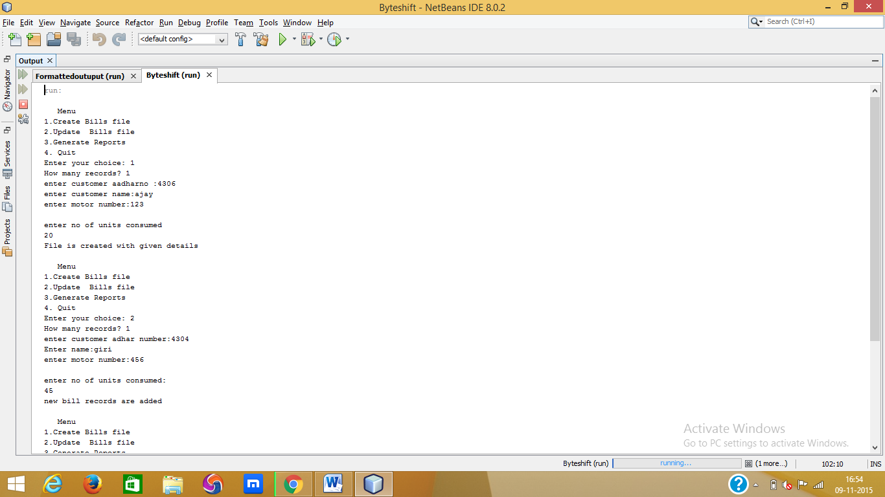

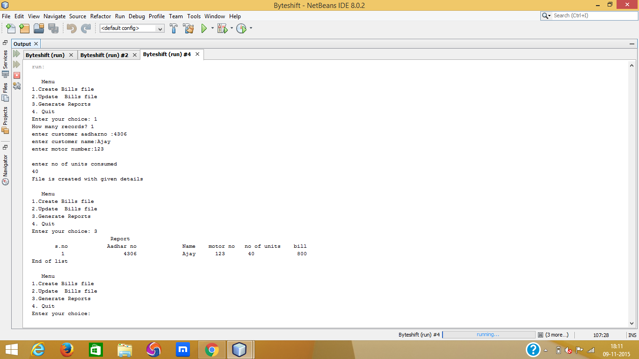
4.3 Module3:

import java.util.*;
import java.io.*;
class Project3 {

public static void main(String args[])
throws IOException {
int i,num,bill;
int choice=0;
int aadharno,intMarks,bill2,pay;
String name,name1,status;
int searchAadharno=0;
boolean flag=true;
int snum;
Scanner obj = new Scanner(System.in);
while(flag)
{
System.out.println("\n Menu");
System.out.println("1. Update bill payments");
System.out.println("2. to notify defaulters");
System.out.println("3. generate report");
System.out.println("4. Quit");
System.out.print("Enter your choice: ");
choice = obj.nextInt();

switch(choice){
case 1:

FileReader fin1 = new FileReader("bill.txt");
Scanner sc1 = new Scanner(fin1);
while(sc1.hasNextInt())
{
aadharno = sc1.nextInt();
name = sc1.next();
intMarks= sc1.nextInt();
int unit = sc1.nextInt();
bill=sc1.nextInt();
int reg1=aadharno;
name1=name;
int motor=intMarks;
int unit1 = unit;
bill2=bill;
System.out.println("aadhar number"+reg1+"\nname"+name1+"\nmotorno"+motor);
System.out.println("\nthe amount to be paid"+bill2);
System.out.println("enter your choice");
System.out.println("1.pay now");
System.out.print("2.later");
pay=obj.nextInt();
if(pay==1)
{
status="paid";
System.out.println("\nyou have paid an amount of"+bill2+"sucessfully");
FileWriter fout4 = new FileWriter("update.txt");
Formatter fmt3 = new Formatter();
fmt3.format("%8d\n%10s\n %2d\n%4d\n%4d\n %10s\n",reg1,name1,motor,unit1,bill2,status);
fout4.write(fmt3+"\r\012");
fout4.close();
}
else if(pay==2)
{
status="unpaid";
Formatter fmt2 = new Formatter();
FileWriter fout4 = new FileWriter("update.txt",true);
fmt2.format("%8d\n%10s\n %2d\n%4d\n%4d\n %10s\n",reg1,name1,motor,unit1,bill2,status);
fout4.write(fmt2+"\r\012");
fout4.close();

}

}fin1.close();break;

case 2:
snum=0;

//Read data from file
FileReader fin2 = new FileReader("update.txt");
Scanner sc2 = new Scanner(fin2);
while(sc2.hasNextInt())
{
aadharno = sc2.nextInt();
name = sc2.next();
intMarks= sc2.nextInt();

int units = sc2.nextInt();
bill=sc2.nextInt();
status = sc2.next();
if("unpaid".equals(status))
{
//Display formatted output
++snum;
Formatter fmt2 = new Formatter();
fmt2.format("%2d.\tAadharno.: %8d",snum,aadharno);
Formatter fmt3 = new Formatter();
fmt3.format("\tName: %10s motor no: %2d Bill:%4d Status:%10s",name,intMarks,bi ll,status);
System.out.println("you have to pay an amount of "+bill+"as water tax");

System.out.println(fmt2);
System.out.println(fmt3);
}
}

fin2.close();
break;
case 3:snum=0;
System.out.println("\t\t\tMarks List of students");
//Read data from file
FileReader fin = new FileReader("update.txt");
Scanner sc = new Scanner(fin);
while(sc.hasNextInt())
{
aadharno = sc.nextInt();
name = sc.next();
intMarks= sc.nextInt();
int units = sc.nextInt();
bill=sc.nextInt();
String status4=sc.next();
//Display formatted output
++snum;//increment serial number
Formatter fmt2 = new Formatter();
fmt2.format("%2d.\tAadharno.: %8d",snum,aadharno);
Formatter fmt3 = new Formatter();
fmt3.format("\tName: %10s MOTORNO: %2d no of units=%4d BILL:%4d %10s",name,intMarks,units,bill,status4);
System.out.println(fmt2);
System.out.println(fmt3);
}
System.out.println("End of list");
fin.close();
break;

case 4: flag=false;
break;
default:System.out.println("Wrong Choice!!");
}
}
System.out.println("Program is over");
}
}

OUTPUT:
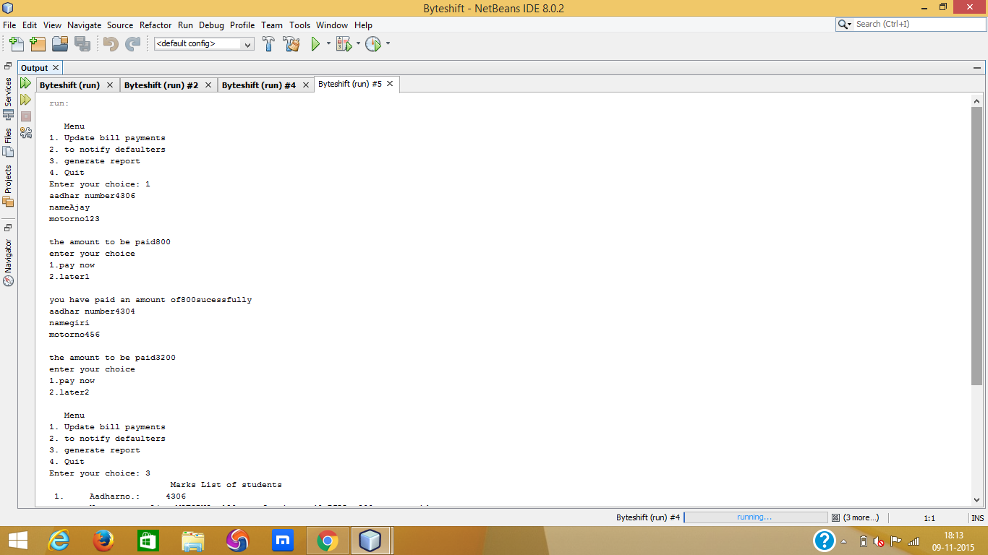
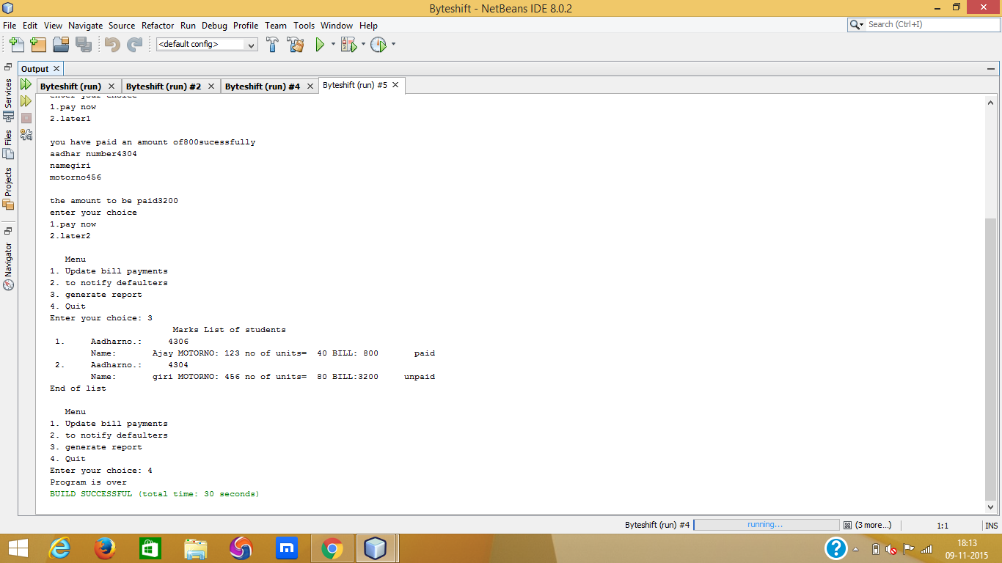

4.4 Module4:

import java.io.FileReader;
import java.io.FileWriter;
import java.io.IOException;
import java.util.*;
public class Integer2
{
@SuppressWarnings("empty-statement")
public static void main(String args[]) throws IOException
{
int choice,i,j = 0,num=0;

Scanner obj = new Scanner(System.in);
String searchString,loginName,passWord, userPassword="Ajay";

while(true)
{
System.out.print("Login name(user/Quit):");
loginName=obj.next();
if(loginName.equals("Quit"))return;

System.out.print("Password:");
passWord=obj.next();
if(loginName.equals("user"))
if(passWord.equals(userPassword))break;

System.out.println("Illegal LoginName or password");
}

boolean flag=true;
while(flag)
{
System.out.println("\n\n Menu");
System.out.println("1. Customer Information");
System.out.println("2. Create Bills");
System.out.println("3. Update Payments");
System.out.println("4. Quit");
System.out.print("Enter your choice: ");
choice= obj.nextInt();
switch(choice){

case 1:
{
boolean flag1=true;
while(flag1)
{
System.out.println("\n Menu");
System.out.println("1. Create Customer File");
System.out.println("2. Add more records to Customer file");
System.out.println("3. Search by Customer aadhar number");
System.out.println("4. Generate report");
System.out.println("5.Quit");
System.out.print("Enter your choice: ");
choice = obj.nextInt();

switch(choice){
case 1:
FileWriter fout = new FileWriter("customer.txt");
System.out.print("How many records? ");
num= obj.nextInt();
for(i=0;i<num;i++)
{
System.out.print("enter customer aadhar number");
int aadharno = obj.nextInt();
System.out.print("Enter customer name");
java.lang.String name=obj.next();
System.out.print("enter house number");
int houseno= obj.nextInt();
System.out.print("enter customer adress");
java.lang.String adress=obj.next();
System.out.print("\n");
Formatter fmt1 = new Formatter();
fmt1.format("%10d\n%10s\n%4d\n%10s\n",aadharno,name,houseno,adress);
fout.write(fmt1+"\r\012");
}
fout.close();
System.out.println("File is created");
break;

case 2:
FileWriter fout1 = new FileWriter("customer.txt",true);
System.out.print("How many records? ");
num= obj.nextInt();
for(i=0;i<num;i++)
{
System.out.print("enter customer aadhar number");
int aadharno = obj.nextInt();
System.out.print("Enter customer name");
java.lang.String name = obj.next();
System.out.print("enter house number");
int houseno = obj.nextInt();
System.out.print("enter customer adress");
java.lang.String adress = obj.next();
System.out.print("\n");
Formatter fmt2 = new Formatter();
fmt2.format("%10d\n%10s\n%4d\n%10s\n",aadharno,name,houseno,adress);
fout1.write(fmt2+"\r\012");
}
fout1.close();
System.out.println("new customer records are added");
break;

case 3: int snum = 0;
System.out.print("enter search Aadhar no: ");
int searchAadharno = obj.nextInt();
FileReader fin1 = new FileReader("customer.txt");
Scanner sc1 = new Scanner(fin1);
while(sc1.hasNextInt())
{
int aadharno = sc1.nextInt();
java.lang.String name = sc1.next();
int houseno = sc1.nextInt();
java.lang.String adress = sc1.next();

if(aadharno==searchAadharno)
{
++snum;
System.out.println("s.no"+" "+"Aadhar no"+" "+"Name"+" "+"House no"+" "+"adress");

Formatter fmt2 = new Formatter();
fmt2.format("%2d %8d %10s %4d %10s",snum,aadharno,name,houseno,adress);

System.out.println(fmt2);
}
}
fin1.close();
break;

case 4:snum=0;
System.out.println("\t\t\tCustomer Details");
FileReader fin3 = new FileReader("customer.txt");
Scanner sc3 = new Scanner(fin3);
System.out.println("s.no"+" "+"Aadhar no"+" "+"Name"+" "+"House no"+" "+"adress");
while(sc3.hasNextInt())
{
int aadharno = sc3.nextInt();
java.lang.String name = sc3.next();
int houseno = sc3.nextInt();
java.lang.String adress = sc3 .next();
++snum;
Formatter fmt2 = new Formatter();
fmt2.format("%2d %8d %10s %4d %10s",snum,aadharno,name,houseno,adress);

System.out.println(fmt2);
}
System.out.println("End of list");
fin3.close();
break;

case 5: flag1=false;
break;
default:System.out.println("Enter correct choice");
}
}
}
break;

case 2: {
boolean flag2=true;
while(flag2)
{
System.out.println("\n Menu");
System.out.println("1.To create Bills file ");
System.out.println("2.To update Bills file");
System.out.println("3.To generate Reports");
System.out.println("4. Quit");
System.out.print("Enter your choice: ");
choice = obj.nextInt();

switch(choice){
case 1:
// Create a file.
FileWriter fout = new FileWriter("bill.txt");
//Read data from Keyboard
System.out.print("How many records? ");
num= obj.nextInt();
for(i=0;i<num;i++)
{
System.out.print("enter customer aadharno :");
int aadharno = obj.nextInt();
System.out.print("enter customer name");
java.lang.String name = obj.next();
System.out.print("enter motor number");
int motorno = obj.nextInt();
System.out.print("\n");//print blankline
// Write to file.
System.out.println("enter no of units consumed");
int units=obj.nextInt();
int bill;
if(units>0&&units<=20)
bill=units*10;
else if(units>20&&units<=40)
bill=units*20;
else if(units>40&&units<=60)
bill=units*30;
else
bill=units*40;

Formatter fmt1 = new Formatter();
fmt1.format("%8d\n%10s\n%4d\n%4d\n %4d\n",aadharno,name,motorno,units,bill);
fout.write(fmt1+"\r\012");
}
fout.close();
System.out.println("File is created");
break;

case 2:
FileWriter fout1 = new FileWriter("bill.txt",true);//true means file will be opened in append mode
System.out.print("How many records? ");
num= obj.nextInt();
for(i=0;i<num;i++)
{
System.out.print("enter customer adhar number:");
int aadharno = obj.nextInt();
System.out.print("Enter name:");
java.lang.String name = obj.next();
System.out.print("enter motor number(2 digits):");
int motorno = obj.nextInt();
System.out.print("\n");//print blankline
// Write to file.
System.out.println("enter no of units consumed");
int units=obj.nextInt();
int bill;
if(units>0&&units<=20)
bill=units*10;
else if(units>20&&units<=40)
bill=units*20;
else if(units>40&&units<=60)
bill=units*30;
else
bill=units*40;
Formatter fmt2 = new Formatter();
fmt2.format("%8d\n%10s\n %4d\n%4d\n %4d\n",aadharno,name,motorno,units,bill);
fout1.write(fmt2+"\r\012");
}
fout1.close();
System.out.println("new records are added");
break;

case 3:int snum = 0;
System.out.println("\t\t\tReport");
//Read data from file
FileReader fin2 = new FileReader("bill.txt");
Scanner sc2 = new Scanner(fin2);
System.out.println(" s.no"+" "+" Aadhar no"+" "+"Name"+" "+" motor no"+" "+"no of units"+" "+"bill");
while(sc2.hasNextInt())
{
int aadharno = sc2.nextInt();
java.lang.String name = sc2.next();
int motorno = sc2.nextInt();
int units = sc2.nextInt();
int bill = sc2.nextInt();
//Display formatted output
++snum;//increment serial number
Formatter fmt2 = new Formatter();
fmt2.format("\t%2d\t %8d %10s %2d %4d %4d",snum,aadharno,name,motorno,units,bill);
System.out.println(fmt2);

}
System.out.println("End of list");
fin2.close();
break;

case 4: flag2=false;
break;
default:System.out.println("Wrong Choice!!");
}}
}
break;
case 3: {
boolean flag3=true;
while(flag3)
{
System.out.println("\n Menu");
System.out.println("1. Update bill payments");
System.out.println("2. to notify defaulters");
System.out.println("3. generate report");
System.out.println("4. Quit");
System.out.print("Enter your choice: ");
choice = obj.nextInt();

switch(choice){
case 1:

FileReader fin1 = new FileReader("bill.txt");
Scanner sc1 = new Scanner(fin1);
while(sc1.hasNextInt())
{
int aadharno = sc1.nextInt();
java.lang.String name = sc1.next();
int intMarks = sc1.nextInt();
int unit = sc1.nextInt();
int bill = sc1.nextInt();
int reg1=aadharno;
java.lang.String name1 = name;
int motor=intMarks;
int unit1 = unit;
int bill2 = bill;
System.out.println("aadhar number"+reg1+"\nname"+name1+"\nmotorno"+motor);
System.out.println("\nthe amount to be paid"+bill2);
System.out.println("enter your choice");
System.out.println("1.pay now");
System.out.print("2.later");
int pay = obj.nextInt();
if(pay==1)
{
java.lang.String status = "paid";
System.out.println("\nyou have paid an amount of"+bill2+"sucessfully");
FileWriter fout4 = new FileWriter("update.txt");
Formatter fmt3 = new Formatter();
fmt3.format("%8d\n%10s\n %2d\n%4d\n%4d\n %10s\n",reg1,name1,motor,unit1,bill2,status);
fout4.write(fmt3+"\r\012");
fout4.close();
}
else if(pay==2)
{
java.lang.String status = "unpaid";
Formatter fmt2 = new Formatter();
FileWriter fout4 = new FileWriter("update.txt",true);
fmt2.format("%8d\n%10s\n %2d\n%4d\n%4d\n %10s\n",reg1,name1,motor,unit1,bill2,status);
fout4.write(fmt2+"\r\012");
fout4.close();

}

}fin1.close();break;

case 2:
int snum = 0;

//Read data from file
FileReader fin2 = new FileReader("update.txt");
Scanner sc2 = new Scanner(fin2);
while(sc2.hasNextInt())
{
int aadharno = sc2.nextInt();
java.lang.String name = sc2.next();
int intMarks = sc2.nextInt();

int units = sc2.nextInt();
int bill = sc2.nextInt();
java.lang.String status = sc2.next();
if("unpaid".equals(status))
{
//Display formatted output
++snum;
Formatter fmt2 = new Formatter();
fmt2.format("%2d.\tAadharno.: %8d",snum,aadharno);
Formatter fmt3 = new Formatter();
fmt3.format("\tName: %10s motor no: %2d Bill:%4d Status:%10s",name,intMarks,bill,status);
System.out.println("you have to pay an amount of "+bill+"as water tax");

System.out.println(fmt2);
System.out.println(fmt3);
}
}

fin2.close();
break;
case 3:snum=0;
System.out.println("\t\t\tMarks List of students");
//Read data from file
FileReader fin = new FileReader("update.txt");
Scanner sc = new Scanner(fin);
while(sc.hasNextInt())
{
int aadharno = sc.nextInt();
java.lang.String name = sc.next();
int intMarks = sc.nextInt();
int units = sc.nextInt();
int bill = sc.nextInt();
java.lang.String status4=sc.next();
//Display formatted output
++snum;//increment serial number
Formatter fmt2 = new Formatter();
fmt2.format("%2d.\tAadharno.: %8d",snum,aadharno);
Formatter fmt3 = new Formatter();
fmt3.format("\tName: %10s MOTORNO: %2d no of units=%4d BILL:%4d %10s",name,intMarks,units,bill,status4);
System.out.println(fmt2);
System.out.println(fmt3);
}
System.out.println("End of list");
fin.close();
break;

case 4: flag3=false;
break;
default:System.out.println("Wrong Choice!!");
}
}
}
break;
case 4:flag=false;
break;
default:System.out.println("Wrong Choice!!");
}
}
System.out.println("Program is over");
}
}

OUTPUT:
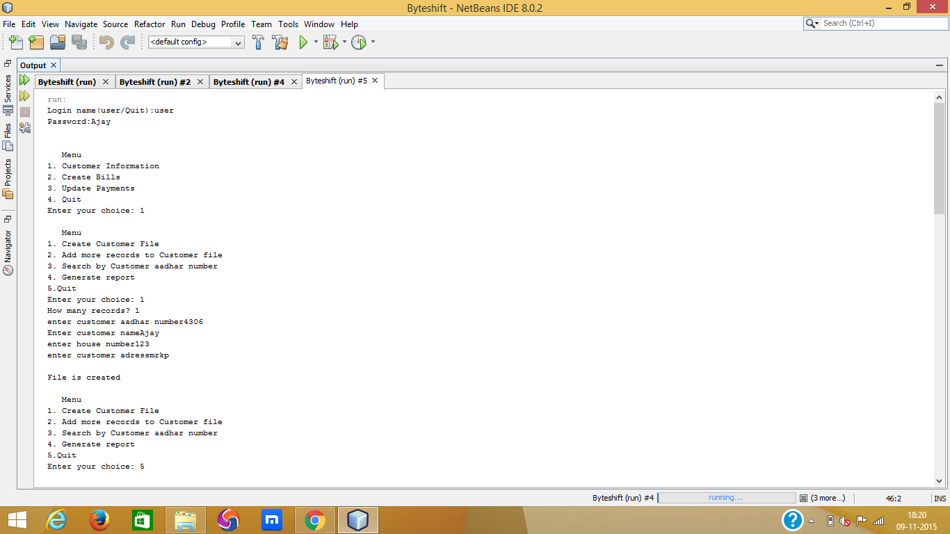
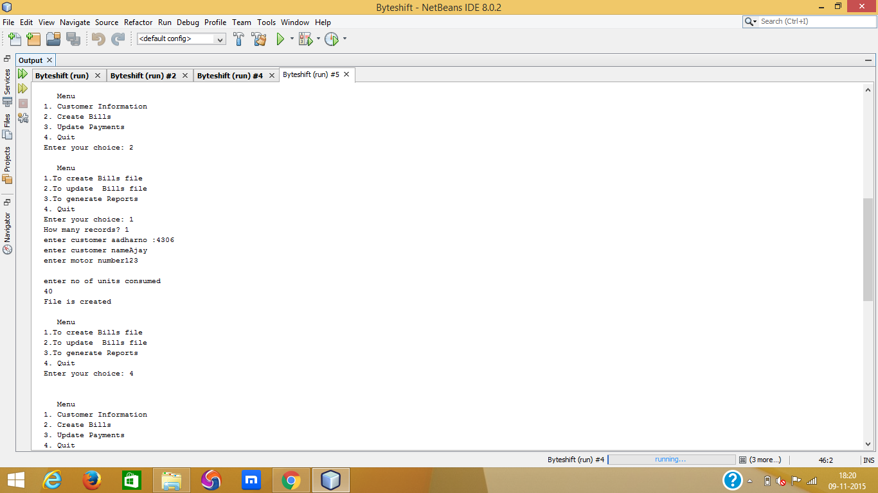

References:
Budd, T. (1997b), An Introduction to Object-Oriented Programming, 2nd edn, Addison-Wesley.
Ghezzi, C., Jayazeri, M. & Mandrioli, D. (1998), Fundamentals of Software Engineering, 2nd edn,Prentice-Hall.
K. Appel and W. Haken. (1976), Every Planar Map is 4-colorable, Bull. Amer. Math. Soc., vol. 82, pp. 711-712

